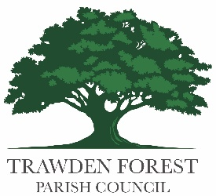

Trawden Forest Parish Council explanation of Section 1 item 7.
In the external audit response from the previous year, it was suggested that, when the Parish Council receives money for grants, this should be off-set against the purchase.
I have since attended training with Eleanor from Do the Numbers, and she advised that this was not the correct way to record grants and associated expenditure.
I have, therefore, reverted back to the original way of recording this as grant income and then the expenditure.
Thank you
Kind regards
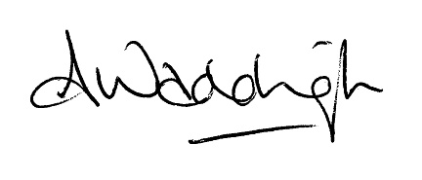

Adele Waddington
Parish Council Clerk and RFO

