Options of screening for the basket swing area at Lanehouse Lane Playground

Option 1 – Willow screening 4m x 1.8m Premium Willow Fencing Screening Rolls – Woven Wood

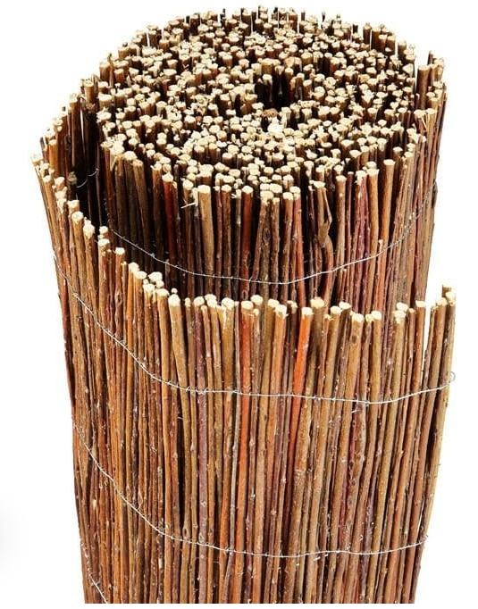

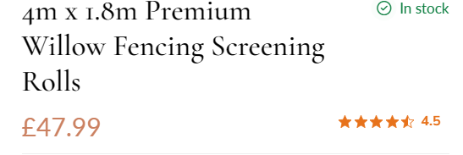

Option 2 - Privacy Screening from Amazon. Gekufa Privacy Netting 2mx10m Garden Screening 130g/m² Fence Screening 90% HDPE Outdoor Shading Net UV-Resistant Tear-Resistant Windbreak Netting with Cable Ties and Eyelets : Amazon.co.uk: Garden
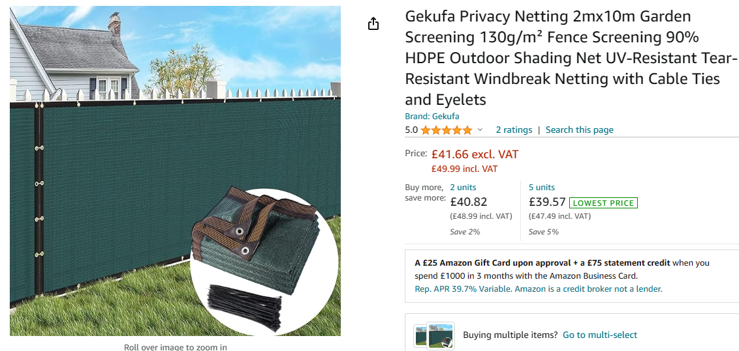

Option 3 - Artificial ivy. Decorative Artificial Ivy Leaf Green Hedge Roll 3m x 1m Privacy Hedging Wall Landscaping Garden Fence UV Fade Protected, Green : Amazon.co.uk: Garden
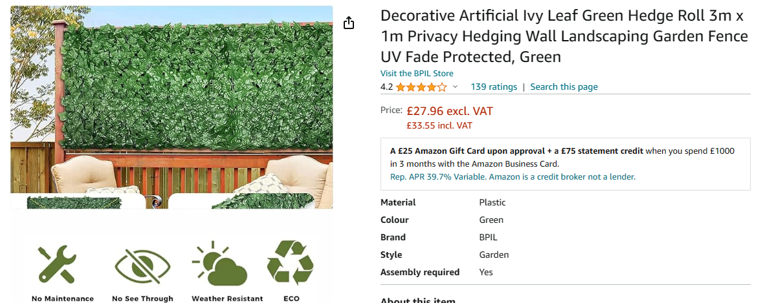

Option 4 – Artificial Conifer Leaf. CHRISTOW Artificial Conifer Leaf Hedge Screening, Outdoor Garden Privacy Screen With Leaves, Wall Fence Panel, UV Resistant, H1m x W3m (3ft 3" x 9ft 10") : Amazon.co.uk: Garden
