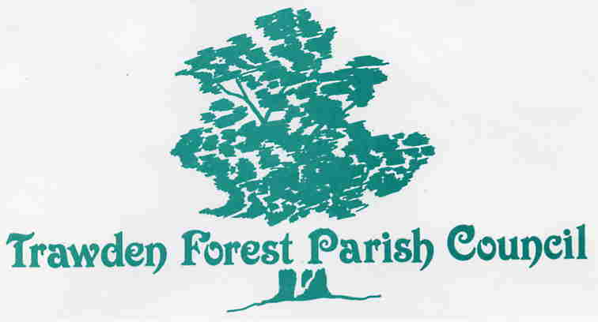

In 2014/5, the Parish Council kept within the budget set, and as the Transparency Code indicates, all expenditure of over £100 must be detailed as below:
May 2014 £244.76 to Zurich Insurance for Liability Insurance
July 2014 £102.57 to Cllr Robinson for reimbursement of expenses incurred for North West in Bloom
July 2014 £868.30 to Gledstone Gardens for Plants
July 2014 £216 to Textstyles for the artwork for the sponsored planters on the wall at Skipton Road, Trawden
July 2014 £492 To Ian Salter Gardening Services for work carried out at Harambee Garden
July 2014 £205 to Birro, Colne for the new poetry plaque at the War Memorial
Sept 2014 £252.60 to PJ Patten for making the Victorian Toilet on Skipton Road safe
Sept 2014 £100 donation to the Church for upkeep of the clock
Sept 2014 £125 donation to Mountain Rescue
Sept 2014 £125 donation to Air Ambulance
Oct 2014 £162 to BDO Auditors
Oct 2014 £450 or to Ian Salter Gardening Services for half year work carried out at Harambee Surgery Garden
Oct 2014 £300 donation to the Community Centre
Oct 2014 £385.80 to Gledstone Gardens for plants
Nov 2014 £756 to Pendle Council for supply of Christmas Tree
Dec 2014 £172.68 to JRB Enterprise for dog fouling bags
Feb 2015 £100 donation to the new Community Centre Friendship Group
Mar 2015 £150 to Whitesides Tree Care for removal of a tree

