CONFIRMATION OF THE DATES OF THE PERIOD FOR THE EXERCISE OF PUBLIC RIGHTS

Name of smaller authority: __Trawden Forest Parish Council______

County Area (local councils and parish meetings only): __Lancashire________

On behalf of the smaller authority, I confirm that the dates set for the period for the exercise of public rights are as follows:

Commencing on __13th June 2022_______________________________________

and ending on __22nd July 2022_________________________________________

(Please enter the dates set by the smaller authority as appropriate which must be 30 working days (i.e. Monday – Friday only, and not Bank Holidays) inclusive and must include the first 10 working days of July 2022 (i.e. Friday 1 July – Thursday 14 July).

We have suggested the following dates: Monday 13 June – Friday 22 July 2022. The latest possible dates that comply with the statutory requirements are Friday 1 July – Thursday11 August 2022.)

Signed: __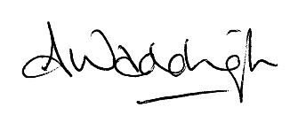___________________________________________

Role: __Clerk and Responsible Financial Officer____

This form is only for use by smaller authorities subject to a review:
Please submit this form to PKF Littlejohn LLP with the AGAR Form 3 and other requested documentation – this form is not for publication on your website.

