CONFIRMATION OF THE DATES OF THE PERIOD FOR THE EXERCISE OF PUBLIC RIGHTS

Name of smaller authority: __Trawden Forest Parish Council______________

County Area (local councils and parish meetings only): _Lancashire____________________

On behalf of the smaller authority, I confirm that the dates set for the period for the exercise of public rights are as follows:

Commencing on ___02/06/2023______________________________________

and ending on ____17/07/2023_______________________________________

(Please enter the dates set by the smaller authority as appropriate which must be 30 working days (i.e. Monday – Friday only, and not Bank Holidays) inclusive and must include the first 10 working days of July 2023 (i.e. Monday 3 July – Friday 14 July).

We have suggested the following dates: Monday 5 June – Friday 14 July 2023. The latest possible dates that comply with the statutory requirements are Monday 3 July – Friday 11 August 2023.)

Signed: ___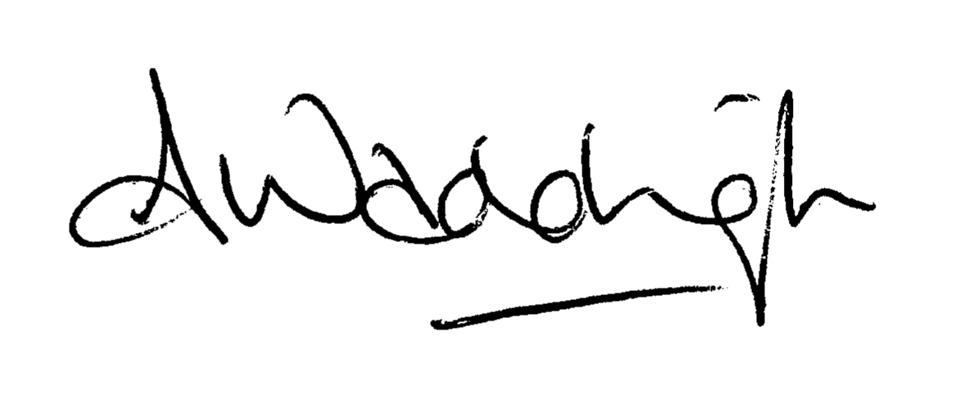__________________________________________

Role: __Parish Clerk & Responsible Financial Officer_________

This form is only for use by smaller authorities subject to a review:
Please submit this form to PKF Littlejohn LLP with the AGAR Form 3 and other requested documentation – this form is not for publication on your website.

