Report – Jan/Feb – 29.02.02024

Monthly update on our weekly activity timetable

Day/Time | Activity | Venue | Funder | Update
Monday 4.30 p.m. – 6.30 p.m. | Youth Club | CYAG HQ | CYAG – Unrestricted reserves | This youth club is very busy, it’s the longest standing session running at CYAG HQ and has over thirty-five of our members registered and attending regularly.  This is run like a traditional youth club with group games, outdoor and indoor activities with refreshments.  This activity is run by two CYAG volunteers and two CYAG youth workers.
Tuesday 4 p.m. – 5 p.m. | Creative Arts | CYAG HQ | CYAG – Unrestricted reserves | This activity is two weeks in. The first five weeks consists of a variety of workshops. These look at different areas of performing arts such as dance, music composition, stage setting, costume design, acting, etc. So far, we have 10 members signed up to this.  This activity has four volunteers, two fully qualified teachers, a musician, and a dance teacher.
Wednesday 4.30 p.m. – 6.30 p.m. | Youth Club | CYAG HQ | CYAG – Unrestricted reserves | This is also two weeks in, replacing the Trawden Youth Club and is run like a traditional youth club with group games, outdoor and indoor activities and often refreshments.  As it’s new to the activities list, we currently have 14 members signed up and on the register for Wednesdays.  This activity is run by a two CYAG Youth Workers.
Thursday 3.30 p.m. – 4.30 p.m. | Cricket | Primet Academy | CYAG – Unrestricted reserves | Cricket is held at Primet Academy and is mainly accessed by pupils from Primet. We have 14 members on the register who are attending regularly at this activity.  It is run by a CYAG Youth Worker and a volunteer cricket coach.
Friday 5.45 p.m. – 8.00 p.m. | Football | FisherMore 3G Pitches | CYAG – Unrestricted reserves | This is still our most popular activity with over one hundred members on the register and a steady flow of young people attending week in week out. Last week, we had fifty-nine members attend. This is run by two CYAG Youth Workers.
Saturday 12.00 p.m. – 13.30 p.m. | Karate | Kanokwai Budo Renmei Dojo | CYAG – Unrestricted reserves | This activity has just begun, following the success of our previous multi discipline sessions and is an eight-week introduction to Karate. We have 11 young people signed up to this activity, all attended in the first week and reported that they really enjoyed it.  It is run by two volunteer Sensei’s at the Dojo and a CYAG youth worker, with support from other dojo members.
Ad-Hoc | Detached | Skipton Road, Sainsbury’s and North Valley Retail Park, Waterside. | CYAG – Unrestricted reserves | Sainsbury’s is still high on the priority list when doing our walk arounds. It is often around there and North Valley Retail Park we encounter the youngest people. Mainly they are seeking shelter, warmth, Wi-Fi and a meeting place for their friends. Some of the older ones, aged 14+ said they would come to CYAG if the sessions were categorised by age group and didn’t have younger children there -only 14 and above. Others talk about specific activities they might attend such as netball. Some of them have come along to Friday Night Football @ Fisher More and signed up to CYAG.  However, of late, it has been quiet on our walk arounds, with us seeing fewer and fewer young people hanging around in larger groups and creating problems in Colne.

Holiday Clubs
Holiday Club | Funder | Venue | Update
HAF – Holiday Activities with Food | Pendle Borough Council/ Lancashire County Council/ British Government | CYAG HQ | We ran four days of HAF in January with thirty young people attending and enjoying various activities planned and led by four youth workers and paid volunteers at CYAG.  We have also been allocated four days over Easter which will also be run by youth workers and youth support workers at CYAG. This holiday club was filled on the day it was launched. We have already begun planning this, our trips using Kermit (our minibus), general daily activities, and provision of food, etc.
Colne Action Club – Members only | Andrew Snowden’s (Lancashire Police and Crime Commissioner) Safer Lancashire Neighbourhoods Fund - 50%  CYAG - 50% | CYAG HQ | We ran three days of holiday provision for our own members over Christmas, staffed by four of our own CYAG Youth Workers and paid volunteers. This was attended by 30 of our own members who were able to take part in a variety of Christmas crafts and activities and a few trips out walking in nature.  We also ran one week of holiday provision during the February Half Term.  Members who attend this provision are not only our own members but over 50% have some form of additional need and require more adult support.

Attendance Data
Over the last nine months we have grown substantially, not just in terms of the youth provision that we are providing for the youth of Colne and its villages of Trawden, Foulridge and Laneshaw Bridge, but, also in the number of young people accessing this provision.
We can see below that in February alone we had 322 registered attendances to our activities.
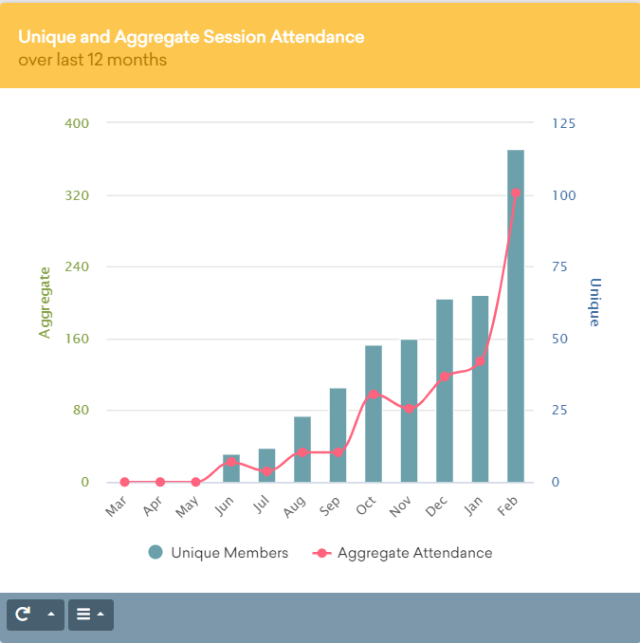

Our attendance data tells us that 78.18% of our attending members are male and the other 21.82% are female.
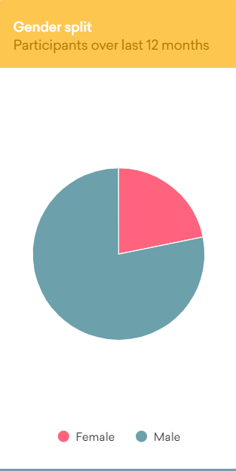

Staffing/Volunteers
At CYAG we now have the following:
1 Full time Senior Youth Worker
1 Part-Time Youth Support Worker
3 Casual Paid Volunteers (holiday clubs, annual leave, illness cover)
1 Part-Time Cleaner
9 Regular Volunteers

Community Networking
Event | Venue | Activity
Winter Bloom Workshop 19.02.2024 | Fran – Artist from Handmade Productions at CYAG HQ | Fran delivered a creative workshop where twelve young people were able to create Mice Lanterns for the WinterBloom24 light festival.
WinterBloom24 Light Festival 24.02.2024 | Colne Town Centre | All the young people who took part in creating the lanterns, were able to meet at the Light Festival and take part with the lanterns they created. They all had a fabulous time and was an amazing experience to be a part of something so special for our hometown.
Connection with Volunteers from Home Start | CYAG | We met with a representative from Home Start. She has a team of volunteers who would like to run a complex needs support group for families of teens with complex needs. We discussed various ideas around this and support that could be provided for these families in terms of parental support and also supporting the independence skills of these young people.
Youth referral panel | Teams x2 | Being a part of the youth referral panel to support young people who are referred in as being at risk of participating in ASB as part of a multi-agency early help process.
Colne ASB Meetings | Colne Town Hall | Meeting with various representatives, businesses in Colne, Police, youth organisations, etc, to discuss local ASB concerns and potential solutions. Last month’s meeting centred on Sainsbury’s and now a further meeting at Sainsbury’s with the Police has been arranged.
Park Primary Play Days | CYAG HQ | Park Primary has started its play day sessions again at CYAG on Thursday mornings. This is a toddler to preschool group to support parents in getting their children school ready.
Kings Orchard | CYAG HQ | On Monday, 4th March we will be planting our Orchard funded by the King’s Coronation Heritage Fund. We have connected with schools, local businesses and our own members families and supporters to volunteer in helping us plant these trees.
Diabetes Peer Support Group | CYAG HQ | Working with a member of the diabetes team at Burnley General Hospital to put on a regular peer support group for young people with diabetes.

Ongoing Building Improvement Works
We are still working on CYAG HQ. Currently, we have the Marmoleum being laid in our blue room, red room, and the soon to be music studio. This week, the floors in these rooms have been damp proofed, screeded and now the marmoleum is being laid.
We have had a utility space fitted into our garage, with a sink and plumbing for a washing machine and dryer. We also have had plenty of storage fitted for our cleaning materials.
We are looking at fitting a private shower space into HQ for those who get particularly muddy on our outdoor adventures.
Swankies of Colne has almost finished making and fitting the colourful Roman blinds that complement our fresh, modern décor.

