From Trawden Wildlife Group.

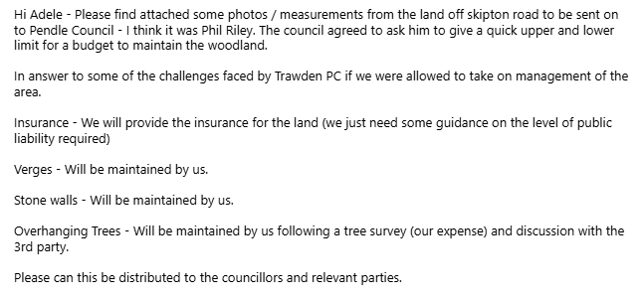

Woodland Off Skipton Road

The photos and information within are intended to provide a rough estimate of ongoing costs / liabilities for looking after the attached pieces of land outlined in red and blue.

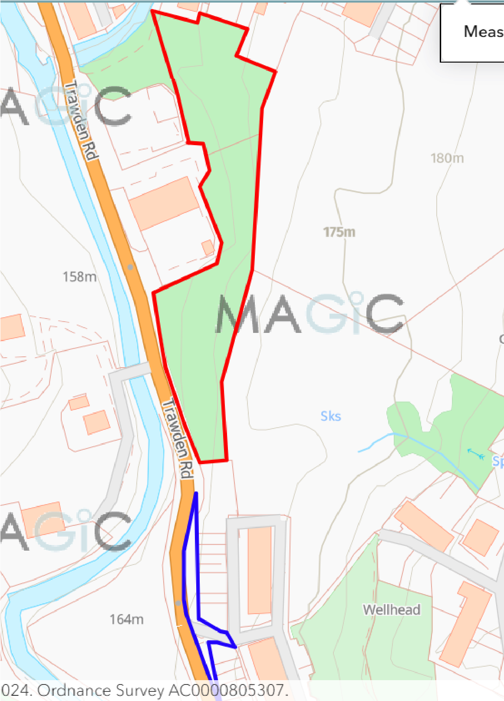

Area in Red “Woodland” - 550m perimeter, 6,601 sq meters
Area in Blue “Verge” - 250m perimeter, 573 sq meters (north grass verge 307 sq meters, south grass verge 101 sq meters)

Verges in ‘blue’ area

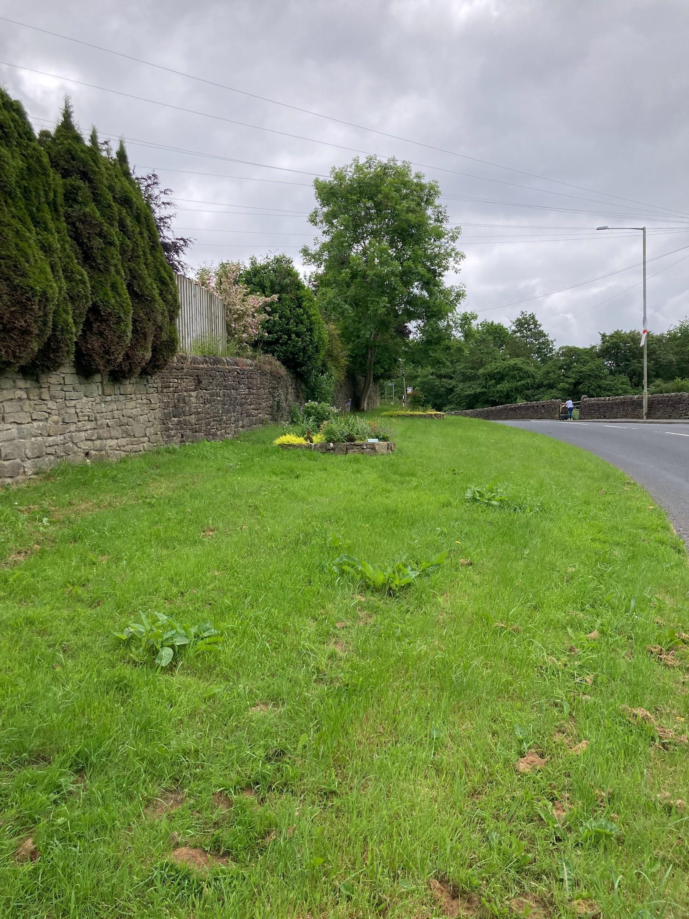

The verge will have to be cut on a regular basis but it is proposed it will be done so on a less frequent basis than currently scheduled to encourage a rich and diverse verge or grass / wildflowers.

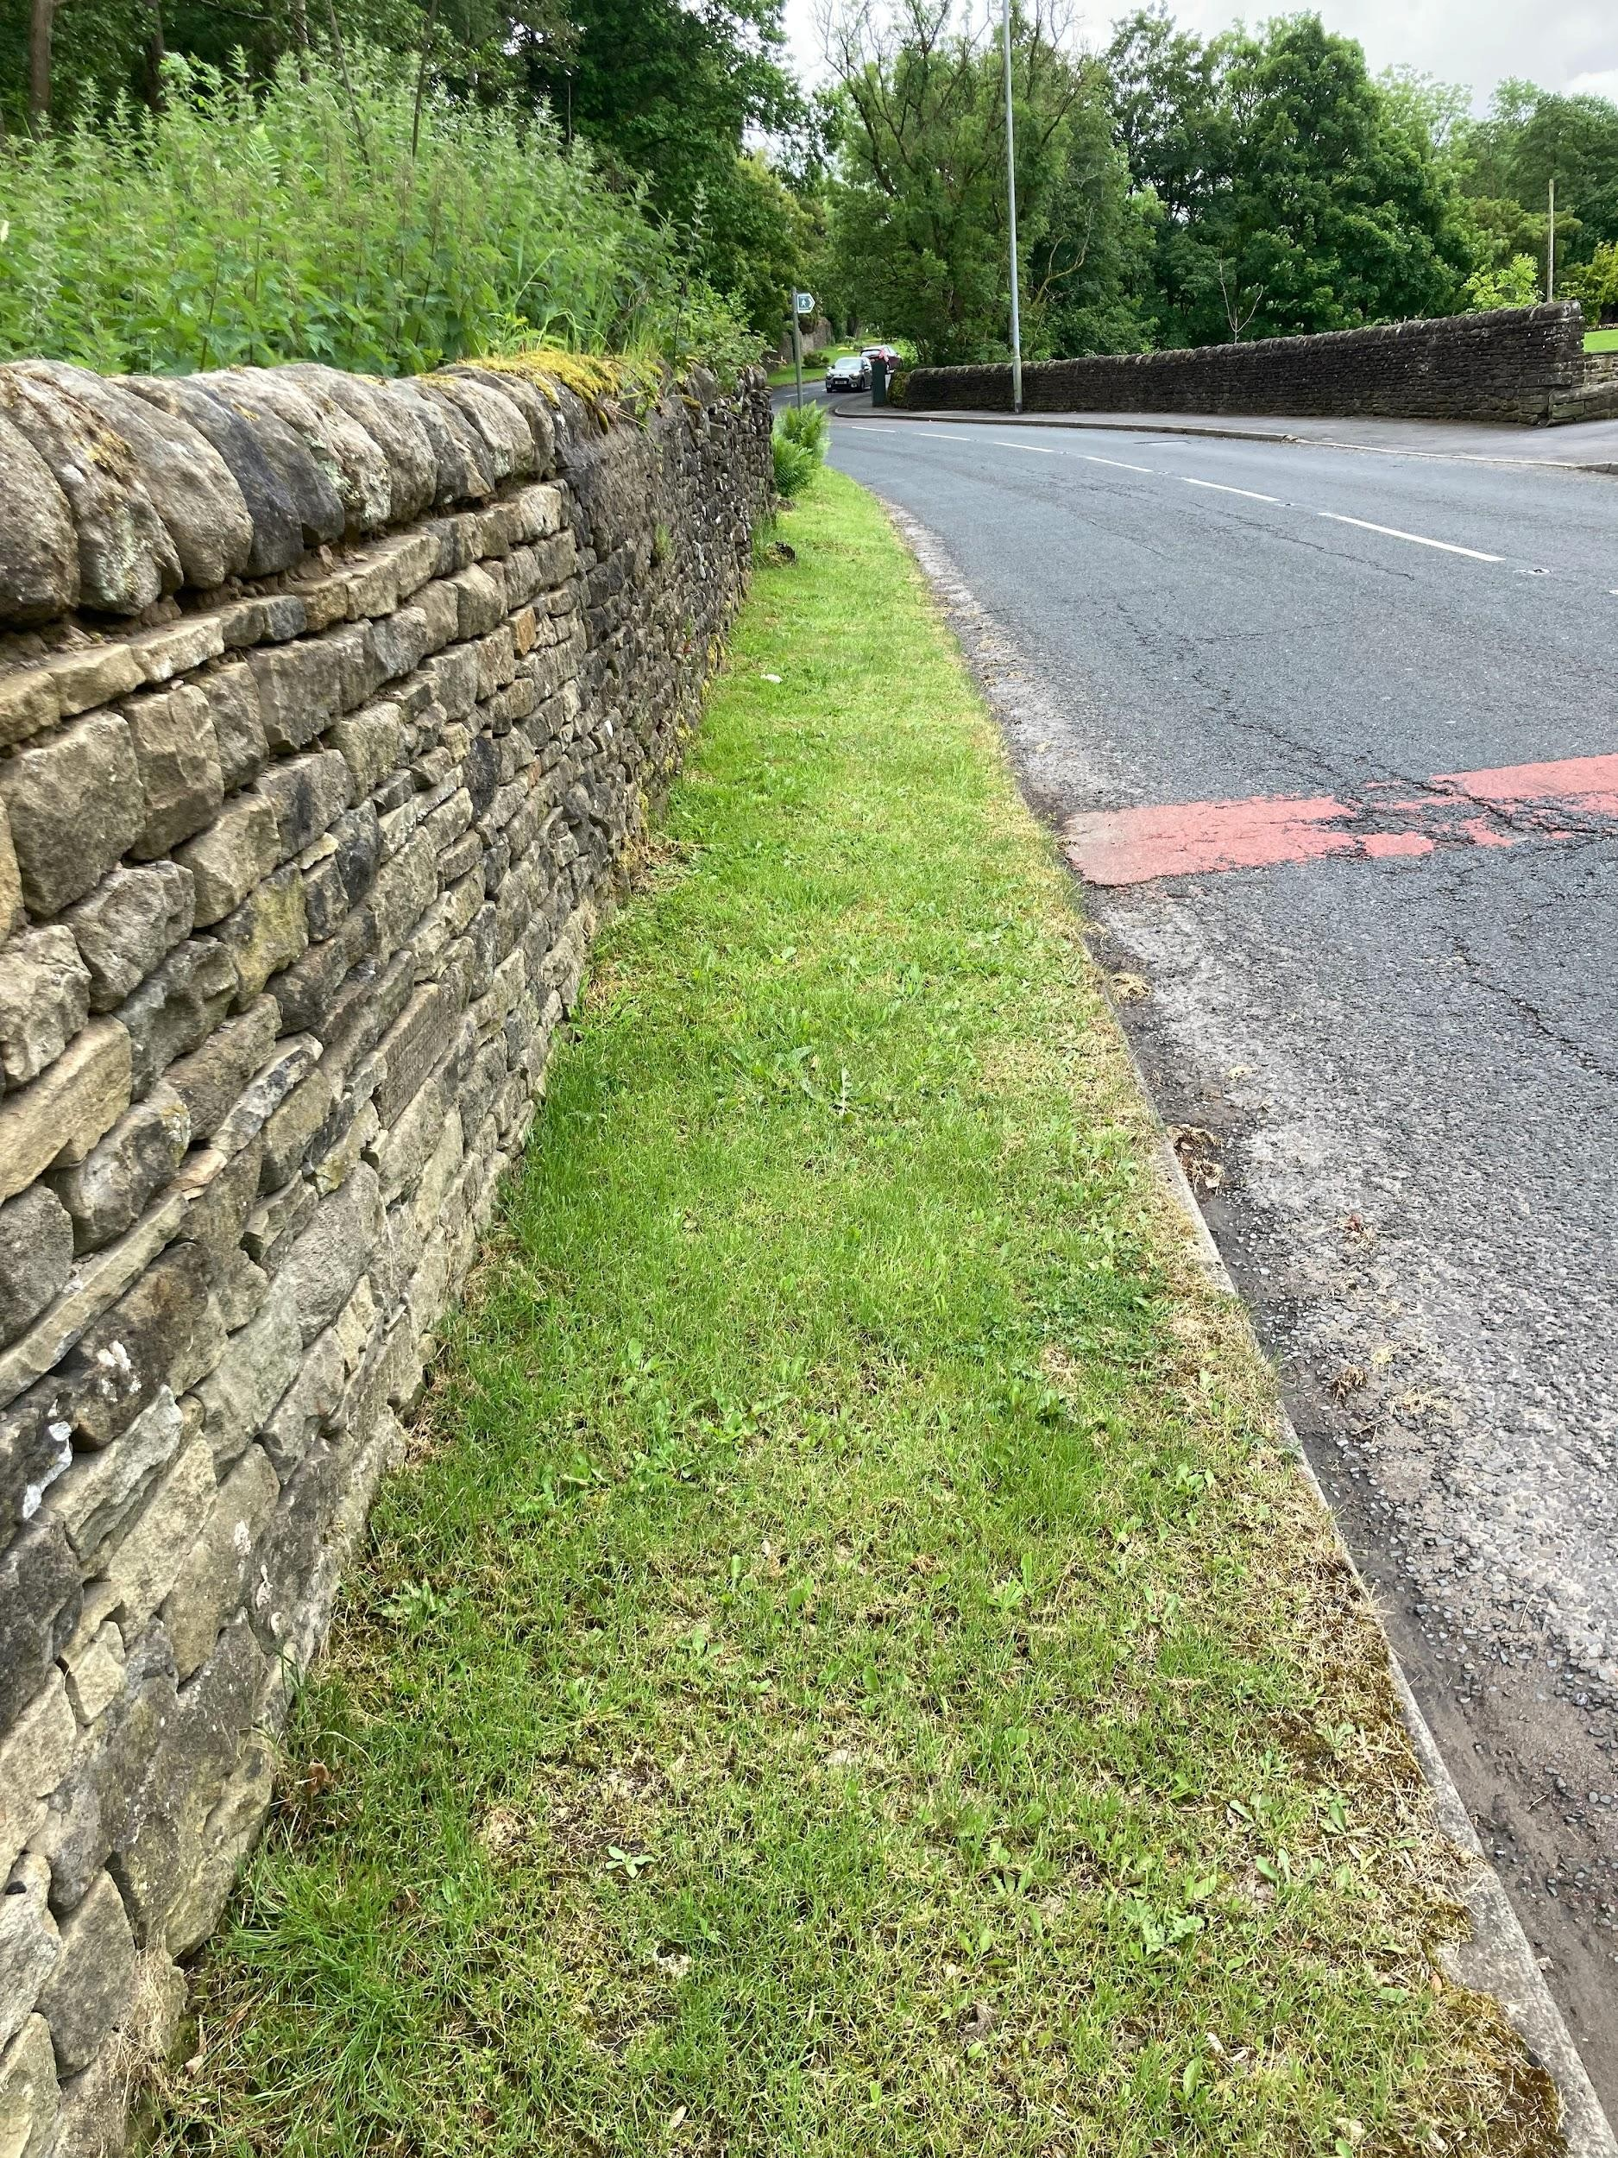

Narrow part of verge also showing a section of the stone wall.

Woodland ‘red’ area

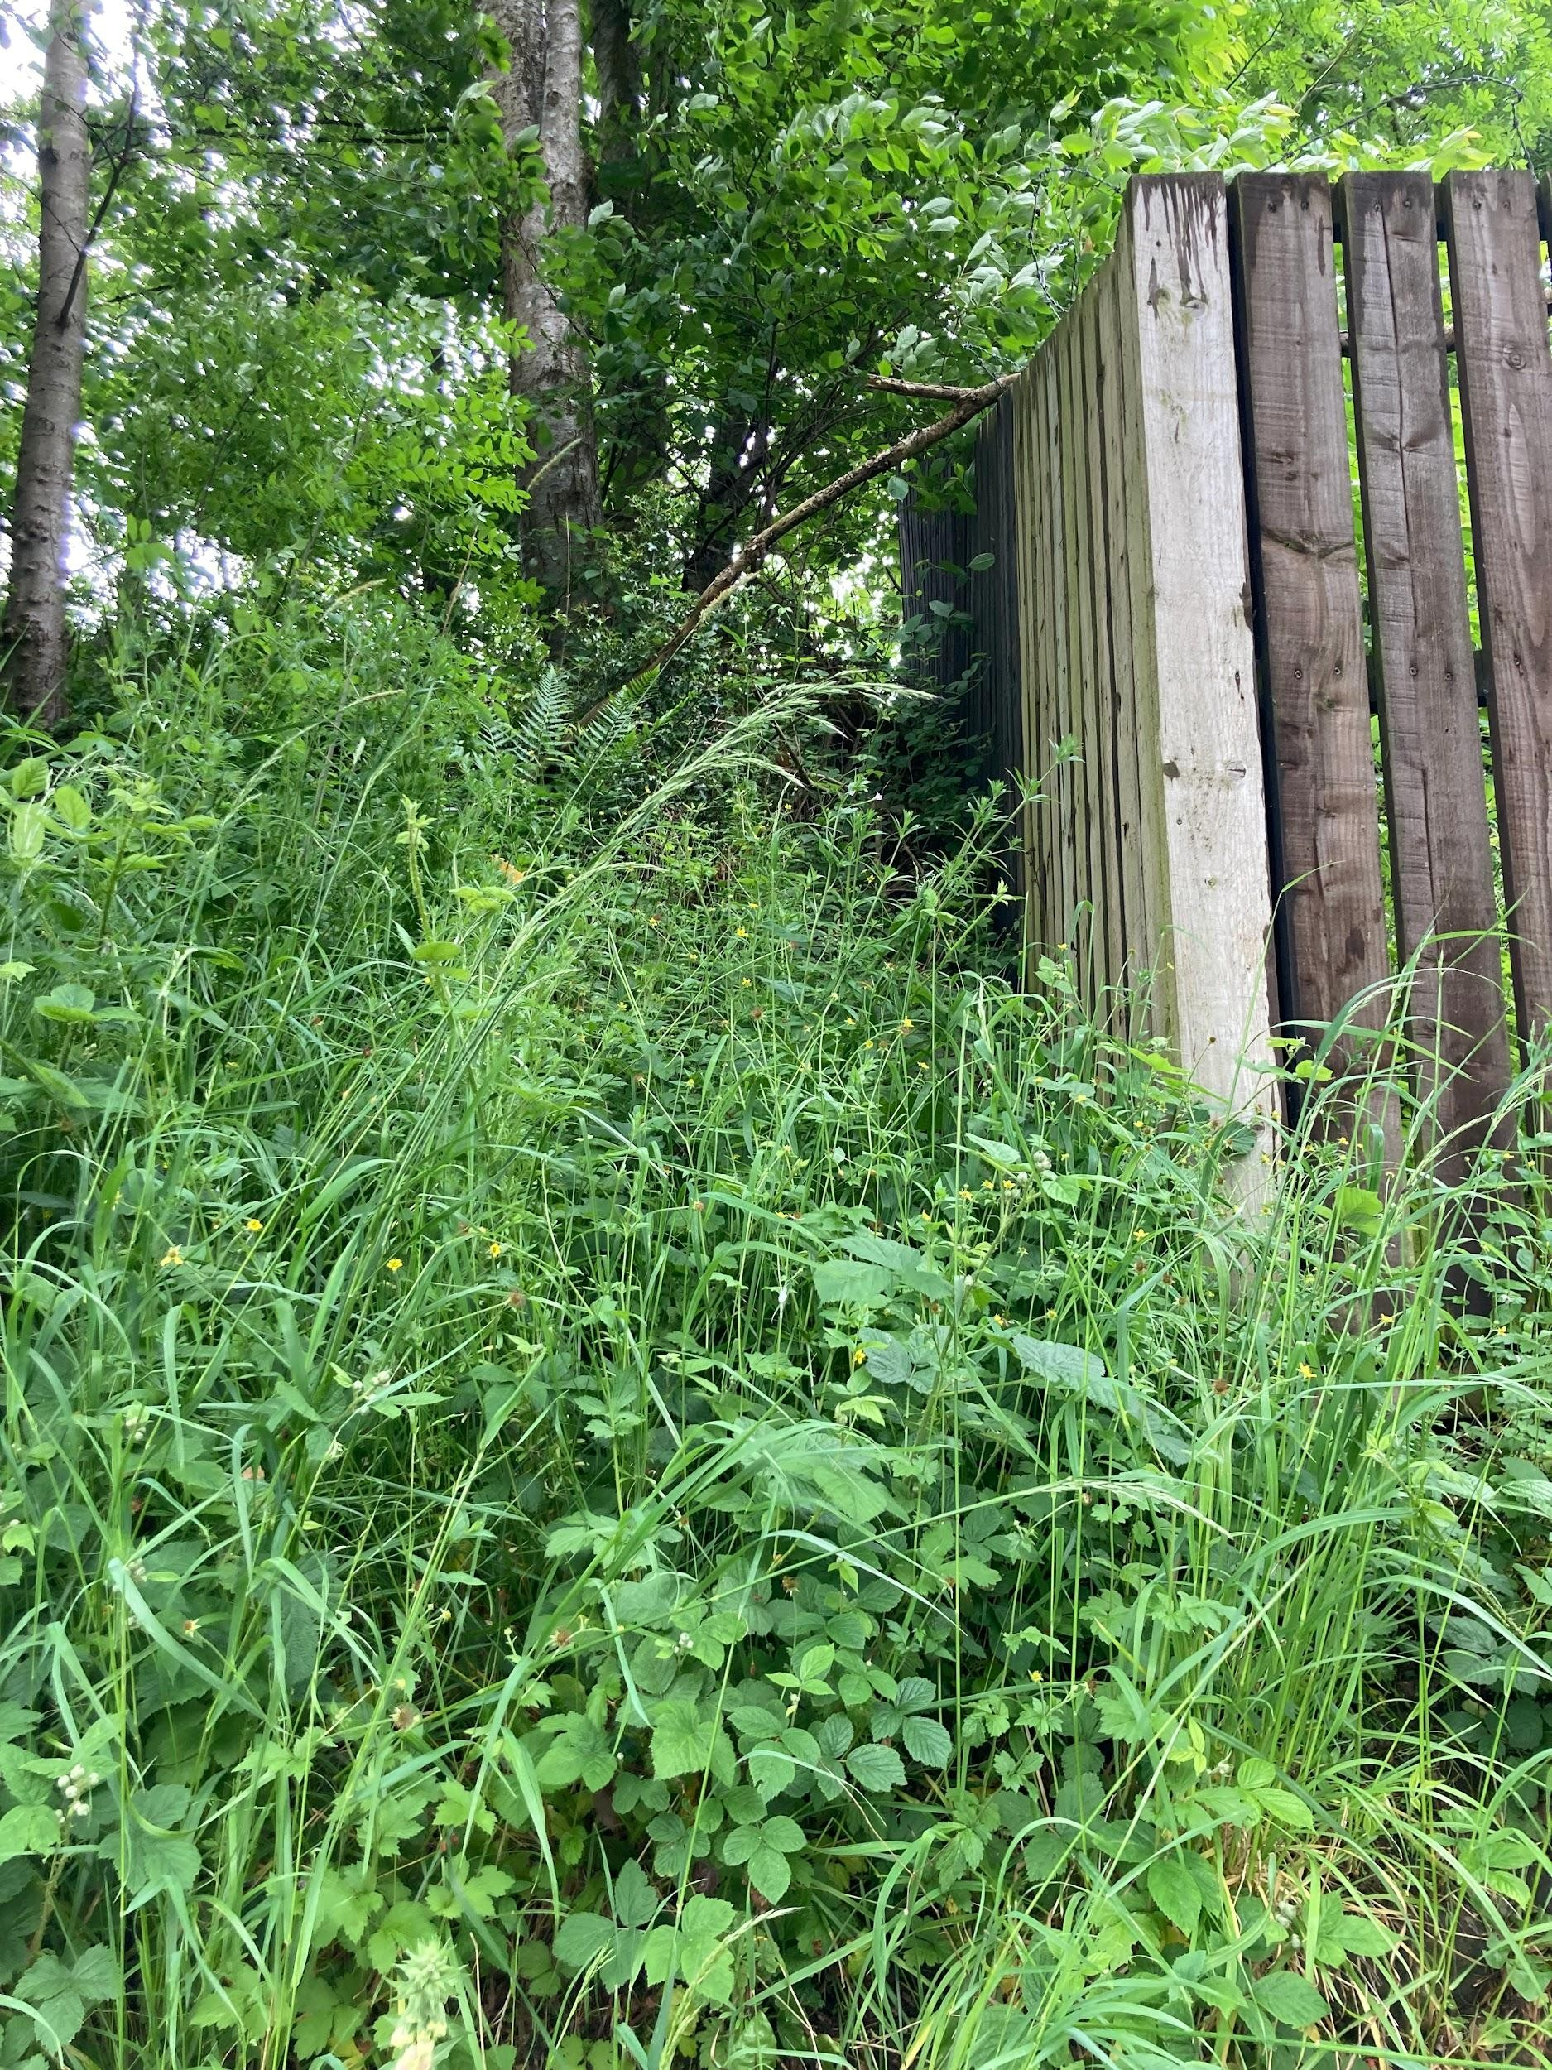

Much of the south border is with gardens of Bankfield street. It is assumed that these boundaries will be maintained by the residents. Any branches that overhang gardens will be managed in agreement with the residents.

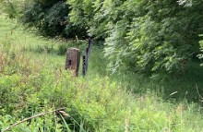

The boundary to the east has a stock proof fence which belongs to the woodland.
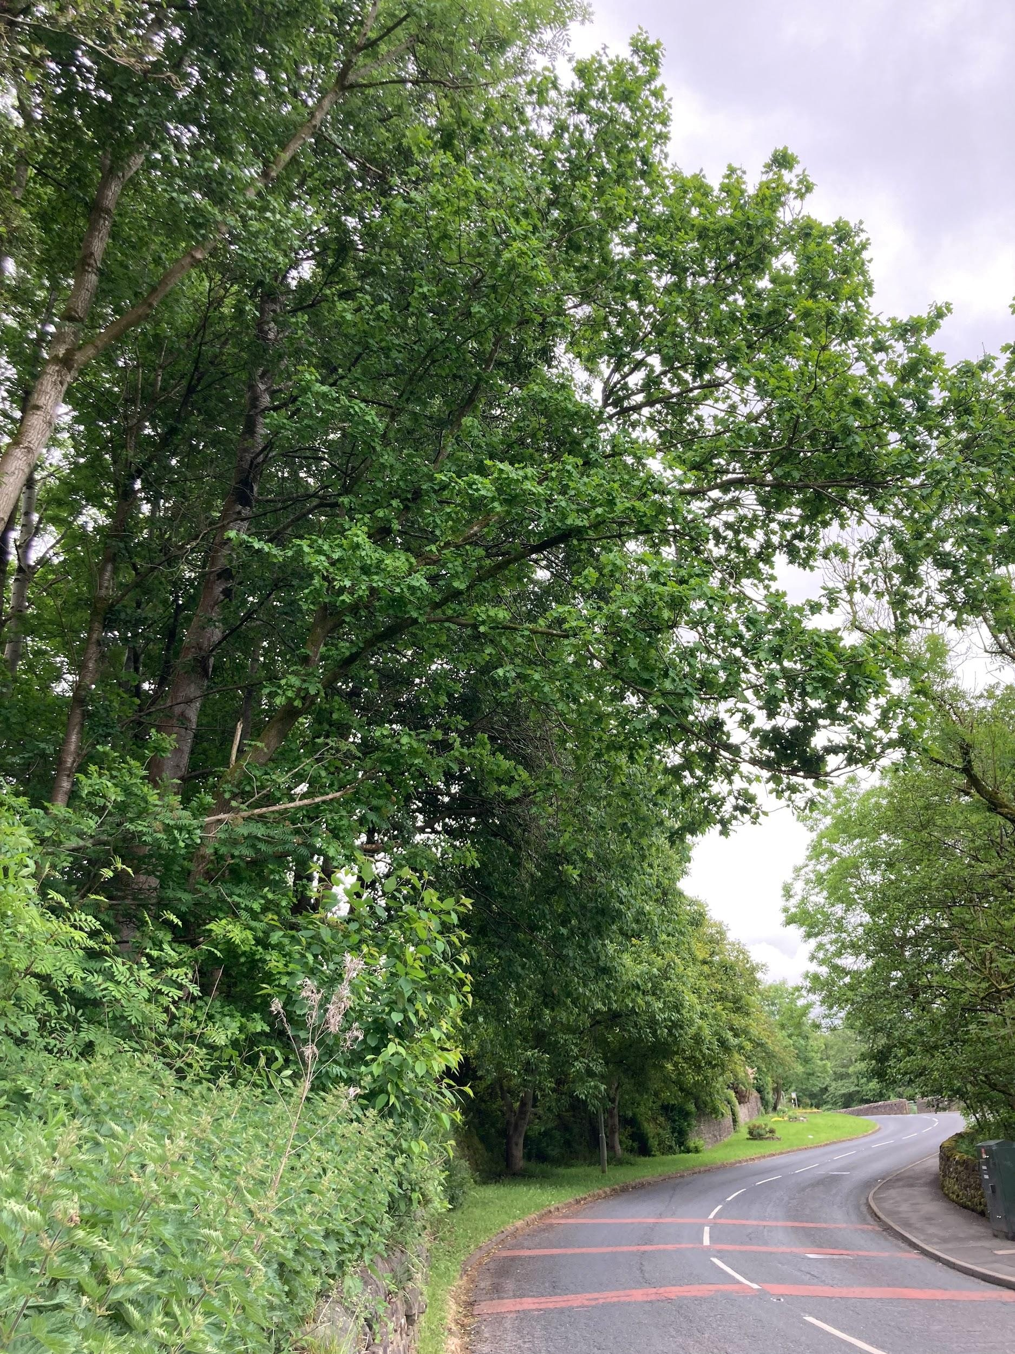

A couple of the larger trees, showing the overhanging branches.

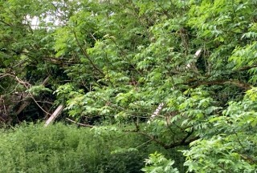

A garden wall that has a boundary with the woodland off Hartington Street is being supported by large timbers. Again, we assume this is the responsibility of the resident to ensure this is secure and safe.

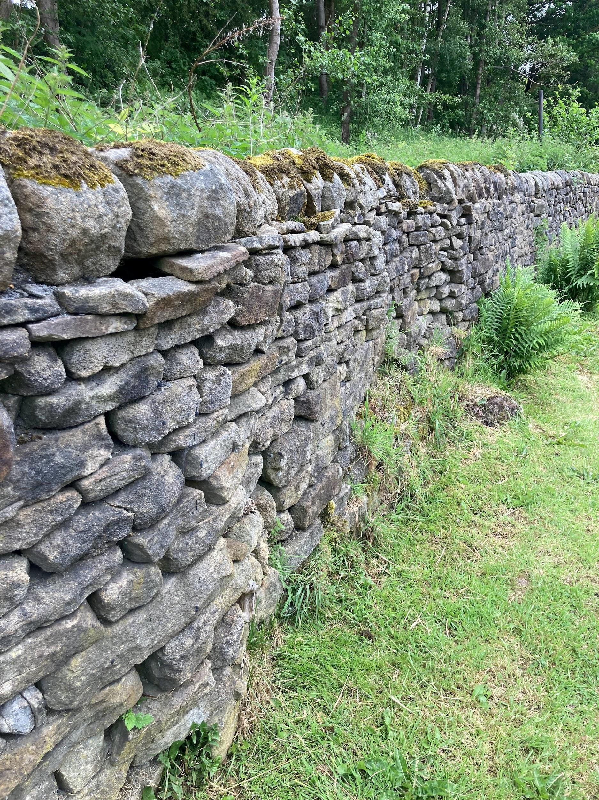

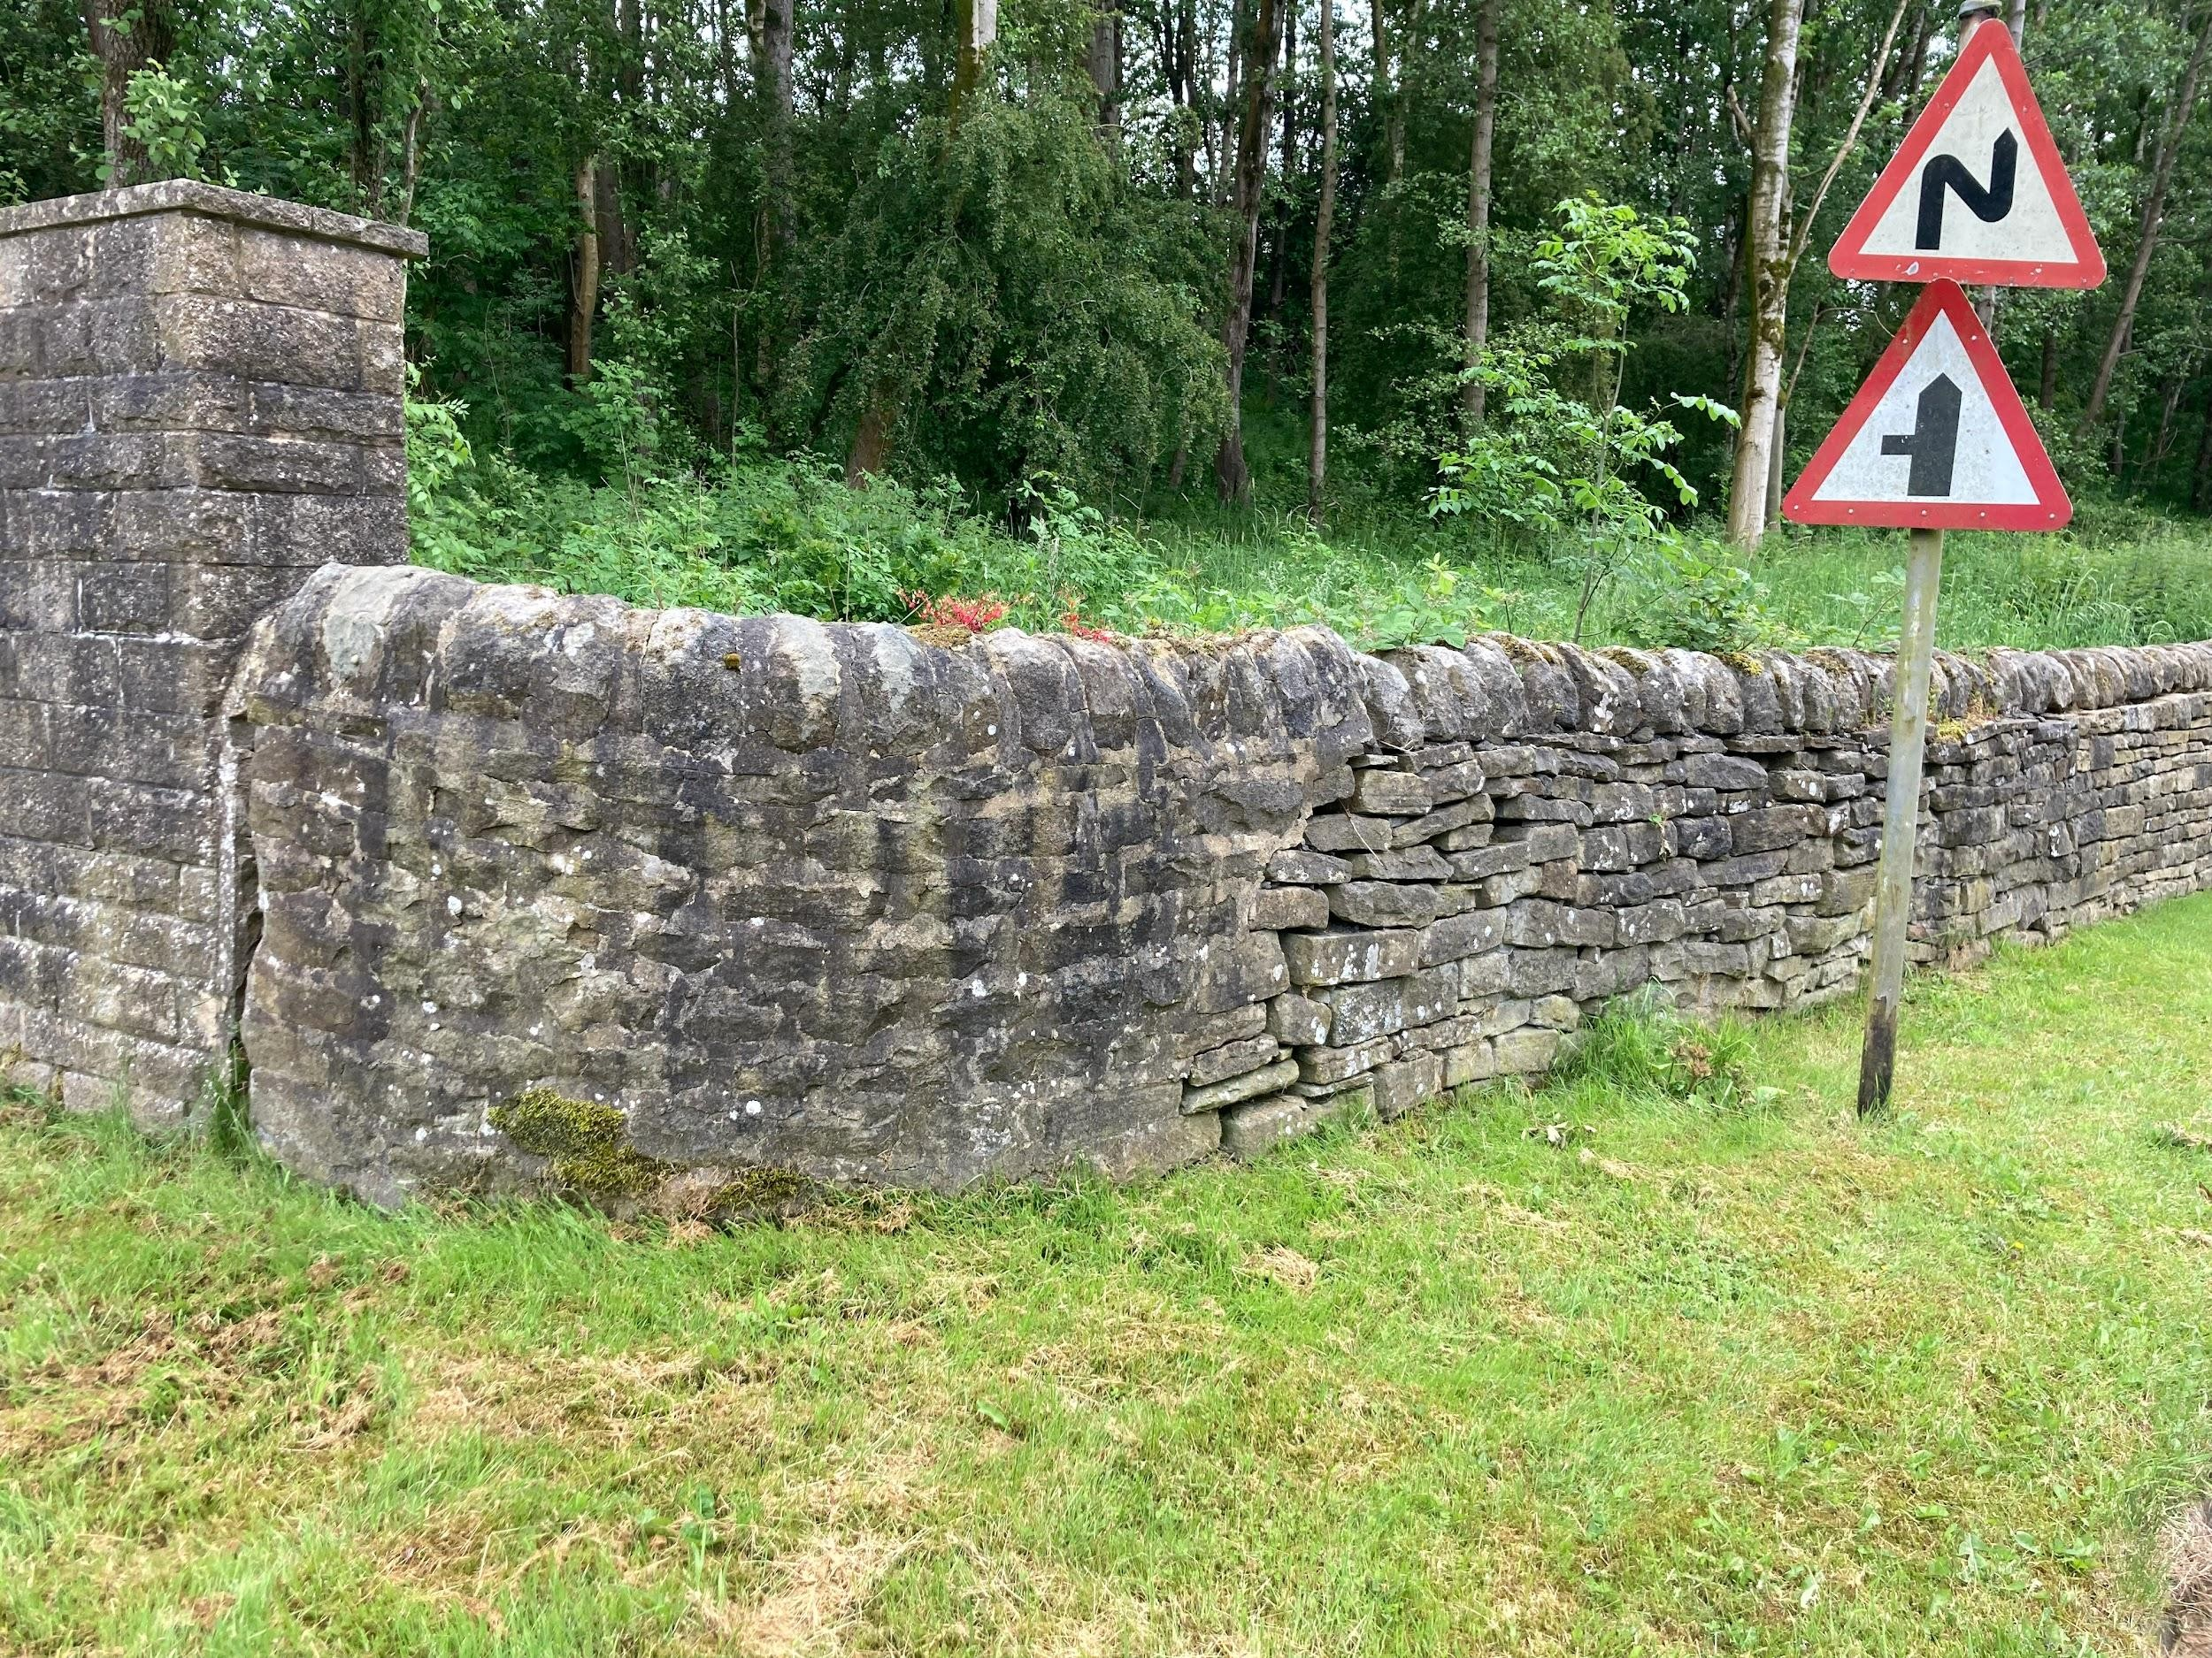
Stone wall at the bottom of the woodland, next to the road verge.
Trawden Community Wildlife Group - Woodland
Management Plan May 2026
Proposal

This plan relates to the land off Skipton Road which is currently owned by Lancashire
County Council and is being considered for transfer of ownership to Trawden Parish Council. Should this transfer go ahead, Trawden Community Wildlife Group proposes that they manage the woodland for preservation and enhancement of the habitats and for the education and enjoyment of the residents of Trawden.

Location
The woodland is located off Skipton Road, Cotton Tree, Trawden. Grid Reference SD 908397. The area measures around 0.75 hectares.
To the East the woodland borders grazing land with a wire fence making the border. To the North, West and South, the woodland borders a road, some houses and industrial yards, mainly with stone walls.

Ecology Overview
The woodland has a canopy of deciduous trees with some standing dead trees and there is a moderate but diverse shrub layer. The majority of the ground layer is made up of nettles, along with a small range of native plants, small tree saplings and a quantity of dead lying wood. There is some encroachment of non-native invasive plants. The woodland supports a wide range of birds.

History
Historically, the area appears to have been grazing land, on which Winewall Cotton Mill was built. This was demolished some time after 1963
This and its proximity to houses and factories would partly account for the high proportion of nettles and invasive species and a small amount of debris such as wire fencing and bricks.

Vision
The long term vision for the area is to manage the woodland sustainably for biodiversity improvement and to protect it from climatic and environmental threats, with the possibility of creating access to the local residents for education and enjoyment.

Management Objectives
Objectives (including environmental, economic and social considerations)
- Maintain a diverse age and species structure throughout the woodland.
- Enhance typical components of native ground flora.
- Maintain the amount of deadwood habitat within the woodland.
- Ensure the site is safe for visitors (under supervision).
- Possible creation of a access for education and enjoyment purposes

Woodland Survey
Information contained in this plan is gathered from a few brief walks through the woodland. It is the intention to carry out a more detailed survey which will be conducted by …. This will enable us to form a more detailed management plan.
Flora - The majority of the area is covered with partly mature small woodland trees, including ash, alder, birch, holly, bird cherry and wild cherry. The shrub layer includes young hazel, hawthorn, guelder rose, ash seedlings, wild rose goat willow and elderberry. The ground layer includes variegated yellow archangel, nettle, celendine, herb robert, ground ivy, wood avens, buttercup and vetch.
Fauna - a wide range of woodland birds have been observed along with pipistrelle bats

Woodland Protection - potential threats
Plant Health
The woodland is in good health but a number of the mature ash have been affected by ash dieback. A more in depth survey of the affected ashes would be necessary.
Boundaries
Currently the site has some damage to the top fence which should be repaired to occlude stock.
Invasive species
There is a significant amount of variegated archangel which will need controlling as it is known to smother native ground flora. There is also an excessive amount of nettle growth which will likely need reducing. There are some other minor infestations of garden plants which need controlling.

Management Objective | Action Needed | Year
Maintain/establish a diverse age and species structure throughout the woodland | Establish the flora and fauna species present in the woodland through a full ecological survey, particularly any ‘at risk’ species and any invasive species. Depending on findings, habitats may need to be maintained or created.  Seek grant aid to fund this. | Summer 2026
Enhance the typical components of native ground flora. | To be achieved by reducing invasive species and excessive growth of over dominant species. Repeated scything/hand-pulling of these species. | Every summer
Maintain the amount of deadwood habitat within the woodland. | Trees will be identified for long term retention as will any standing dead timber. Trees that are selected to be felled will have some of the timber | Summer 2026
 | remain in the woodland and left as habitat piles.
Ensure the site is safe. | Establish state of tree health through a full tree survey to find what safety work needs to be carried out.  Remove rubbish from the woodland floor. Seek appropriate grant aid to carry this out.  Survey the state of the boundaries and seek grant funding for any repairs | All
Possible creation of a access for education and enjoyment purposes | This is a possible future aim which will be explored with appropriate third party agencies.

Financing
If the group were granted a lease, we would presume all costs would have to be covered. At the time of writing, we haven’t been able to assess the land to determine total costs. However, here are some categories and estimates (where we have them)

Item | Cost | Frequency | Details
Insurance | £175 | Annual | Covea Insurance for £1m public liability
Tree Survey | £300 est. | Annual | Needed to understand which trees need  managing  joe@bowlandtreeco nsultancy.com
Mowing | £300 | Annual | Verge mowing
Signage | £500 - £1000 | One Off | To detail what's in the woods - educational

We see the following options for raising money to cover these costs;
Item | Details
Business Sponsorship | “Named Woods” sponsored by - educational signage for the woods
Crowd Funding / Residents | Local campaign to raise funds
Grant Funding | Specific funding - dedicated role within the group
Personal Donations | Individual donations to the cause (some verbally committed already)

We would also look towards volunteer effort where relevant to keep down costs e.g. mowing verges.
Questions for Parish Council
Access - what access can be granted and for what purpose. We would like to see access for management of the woodland and guided access by TCWG for educational purposes (see below).
Funding - what (if any) funding would be available for management of the trees and boundaries.
Insurance - what level of insurance would be required (public liability eg)

