

Members of the Council are summoned to the
Parish Council meeting to be held on Monday 12th April 2021, via Zoom at 7pm

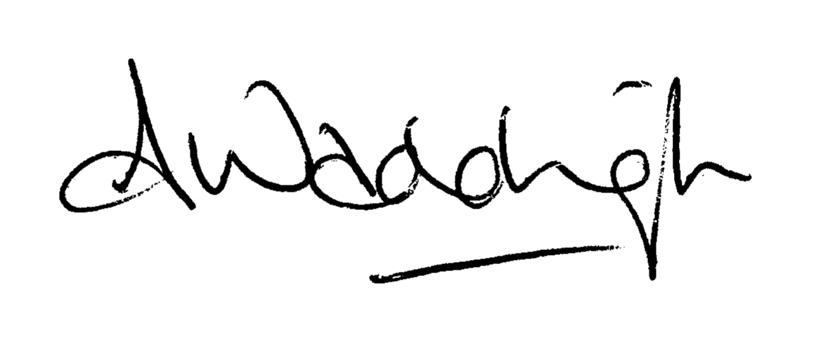
Mrs A Waddington, Trawden Forest Parish Council Clerk and RFO

- To receive Apologies

- To consider and approve the Minutes of the meeting held on 1st and 22nd March 2021 (enclosed)

- To receive Declaration of Interest
Members are to be reminded of the requirements of the member Code of Conduct concerning the declaration of interests

- Jenny Purcell/David Whipp – County Councillors Report - for information only

- Borough Councillors Update - for information only (10 minutes)
On 9th March 2021, the Clerk and Cllr Cockburn-Price met with concerned residents regarding the state of the track from Standroyd Road to LBS. Whilst walking the path, it was noted that 2 ‘short cuts’ have been established running from the track to the rear of the garages at the end of Lambeth street. It would benefit from 2 or 3 steps being created and some hardcore onto the surface to make it safer. It is currently very muddy and slippery. The track also needs a replacement gate and posts at the top of the tracks, and repairs to the steps accessing Ball Grove Drive at the bottom of the Track. The Lengthsman has submitted quotes for work that needs to be completed. Cllr Cockburn-Price has agreed to fund the works required from her Borough Councillors Capital Funding pot. Quotes attached.
Clerk was asked to quote for 2 x Finger Posts; one for the top and one for the bottom of the Tram Tracks. Quote received and attached. Cllr Cockburn-Price has also agreed to fund these from her Borough Councillors Capital Funding pot.

- Community Centre Trustees Update – for information only

- To adjourn the meeting for public participation for their Issues – 5 minutes per item. As the meeting is taking place virtually, if you would like to attend, please contact the Clerk.
Members of the public may make representation during this period and raise issues of local concern, however, please note that the Council cannot make any decision on any matter raised which has not already been included on the formal agenda for the meeting. Such items may be considered for a future meeting. A member of the public is defined as a person, other than Parish Council members or officials.

Chairman to reconvene the meeting

- Lengthsman. Clerk to report on the Lengthsman’s tasks completed for the previous month, and ask Councillors to consider any tasks that should be added to his schedule for the upcoming month. Councillors to consider trimming the tree behind the bus terminus. It is over-hanging.

- Trawden in Bloom.
Councillor Robinson to report on the work carried out by the Trawden in Bloom team. The entry form for the NWIB Competition has been completed and submitted.
Damage has occurred at the Millennium Garden where the Barnfield sponsored bench has been destroyed. The Clerk has arranged for an old bench, currently in storage to be repaired and repainted. Barnfield have agreed to the cost of this, and works have been ordered. (5 minutes)

- Allotments and Garages. To note any issues Councillors D&C Storey report regarding Allotments and Garages.
Councillors to note that the invoices for garage and allotment tenancies have been distributed. Payment expected by the end of April unless the tenant chooses to pay by Standing Order.
Email received from a relative of a tenant who has passed away. Councillors to consider the attached proposal.
Councillors to consider the purchase of wire fencing for dividing of an allotment at a cost of £45.68 + VAT. This is to ensure the tenant of the newly created plot does not have goats intruding and eating any produce grown.

- Ball Grove Park. (10 minutes)
Councillors to consider the attached correspondence from the new owners of The White House (not for public view). Cllr’s Hodgson, D Storey and the Clerk have subsequently met with Philip Mousdale to discuss the proposals. Pendle Borough Council to cost up the new post and rail barrier to stop vehicles accessing the playground. The Clerk proposed that a legal document be drawn up with the residents of the 2 properties and the Council regarding the open access that The White House are looking for.
The Clerk has also been in contact with the Solicitor to request land searches do take place, but to hold off any legal work until the issues outstanding have been resolved. Client Information documents have been completed and returned.
Clerk has been received responses to queries from Pendle Borough Council; see attached. Councillors to consider the responses as attached.

- Map of interesting places. (5 minutes)
The Clerk put out a plea on Social Media and the website to see if there was anyone interested in looking at this. A local lady has responded who is freelance and is currently working on a project for Colne regarding maps. Councillors to consider a short meeting with this person to ensure she has the relevant information required to progress this forward.

- Silver Birch Tree at Cotton Tree. (3 minutes)
Meeting is on 31st March 2021

- Colne Area Committee – for information only (5 minutes)

- Friends of Trawden Playground (10 minutes)
To consider the attached report from the with reference to the Wheel Park/MUGA and upgrades to playground.

- To review the issue of escaping water at Bright Terrace. (4 minutes)
As reported at the last meeting, Pendle Borough Council has done some remedial works. The Clerk has received a report from the resident concerned that the remedial works appear to have improved the situation

- Swim Passes. (4 minutes)
Councillors to note that Cllr Crompton has spoken to Trawden School regarding the rules for swim passes. This will go live at the school holidays at the end of May.

- Application for a Grant (5 minutes)
Councillors deferred a decision on the application for £500 from the Bowling Club until information had been received regarding their plans to promote the Club. Councillors to consider the attached report received regarding awareness raising and to decide whether the grant should be approved.

- National Association of Local Councillors joining fee (8 minutes)
As requested at the last meeting, the Clerk has contact NALC to find the joining fee for April 2021. Councillors to consider the attached costs and information.
- Dog Fouling Issues (5 minutes)
As reported at the last meeting, more complaints are being received regarding dog fouling. Cllr Crompton to update Councillors

- Offers of CCTV at Trawden Road. (8 minutes)
We have received 2 very kind offers of CCTV coverage for the area at Trawden Road that was vandalised:
- ‘I am willing to put a 2 camera system across from the shepherd for £100. Just to cover most of the cost and I'll cover rest. Do you think this would be good? Is there a person that would be willing to have them? Would a few people put to? The 2 cameras would cover up and down the street as well. Can you help set this up?’
- ‘I've recently seen the damage caused to the sheep and shepherd, which is absolutely disgusting. I noticed alot of people asking about cctv. I'm willing to Install and supply a battery operated cctv unit which I can mount out of the way. The device its self is normally used to catch people fly tipping. So, the is no reflective parts to it and also does not light up at all, so quite well hidden. If this would be helpful and you would like me to sort it out please just let me know. Again I would not be charging for this.’
In the meantime, Cllr Cockburn-Price has funded another wildlife camera, that has now been purchased and is it situ. Councillors to consider whether this is sufficient or whether CCTV should be installed.

- New Notice Board outside Community Centre. (5 minutes)
Councillors agreed at the budget meeting to fund a new Parish Council notice board in the new bus shelter outside of the Community Centre. The Clerk has investigated and Councillors to consider purchasing an aluminium magnetic external notice board which is very similar to the one installed at Ball Grove. It is 1050 x 750 x 30mm and only weighs 9kg. It comes with a 5 year warranty and costs £199.73 + VAT (£239.68).

- May Meetings (10 minutes)
Councillors to consider the date proposed for the May Annual Parish Meeting, Annual Parish Council Meeting, and the Ordinary Parish Council Meeting. Information has been received that the Government have confirmed that all meetings from 7th May 2021 must be face to face. The Community Centre have been advised that they cannot open until 17th May 2021. The Law states that Council meetings must take place within 21 days of the election. It is also suggested that residents attend by remote means to reduce the number of people within the building. Current scheduled meeting date is 10th May 2021.

- To consider Planning Application: None

- Correspondence – to consider and resolve to take action on the attached correspondence.

- Finance - To approve, or otherwise the following payments:
Lengthsmans hours £555
Reimburse to Lengthsman for stone needed for Peace Garden Project £307.24
Grass Cutting Contract £160
£130 to Leo Brightley for Cleaning Bus Shelter
Councillors informed that the £100 excess that the Parish Council had to pay for the replacement bus stop has been recovered by a third party and paid into the Parish Council bank account.

- Councillors Issues - To bring to the attention of the Parish Clerk any outstanding issues requiring attention. The Clerk should then pass these onto the relevant authority for action, or add to the agenda for the next meeting.

Next meeting to note that the Annual Parish Meeting and Annual Parish Council meeting are to take place prior to the ordinary Parish Council meeting on TBC May 2021. Commencing at 6.30pm.

